**Sir Syed University of Engineering & Technology**

ANSWER SCRIPT

|  |  |
| --- | --- |
| Date: | June 9,2021 |
| Roll Number: | CS19-037 |
| Section: | A |
| Name: | Munib-ul-hassan |
| Course Name: | Database Systems (CS-329) |
| Degree Program: | BSCS |
| Total number of pages being submitted: |  |

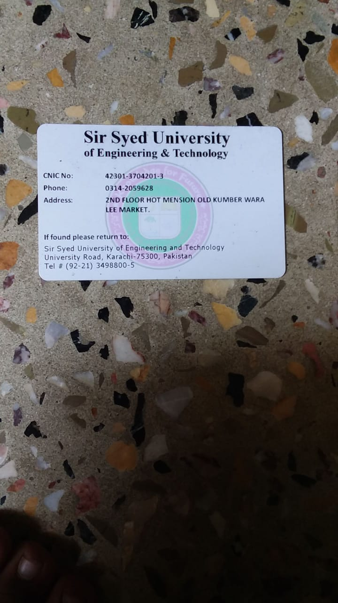



**ANSWER:01:**

**CNIC:** 42301-3704201-3

**(**4+2+3+0+1+3+7+0+4+2+0+1+3)/13 = 30/13 = 2.3 =2

**CLASS MANAGEMENT MODULE**

**ANSWER:02:**

1. Insert into R values (“42301-3704201-3”,”2019-CS-037”,”Munib ul hassan”, “Karachi”,”75660”)
2. Checkinf for attribute keys:

ABE+ ABCDE

ABD+ ABDC

ABC+ ABCD

ABCD+ ABCD

ABCE+ ABCDE

ABDE+ ABCDE

Candidate key = {ABE+}

Super Keys = {ABCE+, ABDE+}

1. Remaining FD’s

A 🡪 C , D, E, B

B🡪 C, D, E

B 🡪 A

1. Axioms:

🡪Reflexivity

E 🡪D

🡪 Composition:

A,B 🡪 C

E 🡪 D

⸫ A, B,E 🡪 C,D

🡪Augmentation:

E 🡪 D

Then,

EA 🡪 DA

**ANSWER:03:**

**Student (SID, Sname, SRollNo, SAddress, SContactNo)**

**Project (PID, PTitle, PMembers, PStatus)**

**Supervisor (SupID, SupName, SupEmail , SupDesignation,SupContactNo)**

1. [insert](http://localhost/phpmyadmin/url.php?url=https://dev.mysql.com/doc/refman/5.5/en/insert.html) into Student(Sname,SRollNo,SAddress,SContactNo) [values](http://localhost/phpmyadmin/url.php?url=https://dev.mysql.com/doc/refman/5.5/en/miscellaneous-functions.html#function_values) ("Munib",037,"leamarket","+923142059628")
2. [insert](http://localhost/phpmyadmin/url.php?url=https://dev.mysql.com/doc/refman/5.5/en/insert.html) into Project(Ptitle,Pmember,PStatus) [values](http://localhost/phpmyadmin/url.php?url=https://dev.mysql.com/doc/refman/5.5/en/miscellaneous-functions.html#function_values) ("Munib",5 ,"5th grade")
3. [insert](http://localhost/phpmyadmin/url.php?url=https://dev.mysql.com/doc/refman/5.5/en/insert.html) into SuperVisor(SupName,Supemail,SupDesignation,SupContactNo) [values](mailto:values) ("Munib","Munibkhatri123@gmail.com","Owner", "+923142059628")
4. There is no common attribute in both table so we cannot join them selves so this querry is not valid
5. IISupContactNo (σ SuperDesignation= "Lab Teacher" (SuperVisor))
6. σ Ptitle LIKE "Management" (Project)
7. *ρ PTitle-Database CS0329 /*PTitle(Project)

**ANSWER:04:**

**ANSWER:05:**

The given schedule is not conflict- serializable because the paerendecy graph we get is cyclic and the condition to be conflict-serializable is that the procederay graph of schedules should be Acyclic.

**PART A:**

We convert the given transactions by adding locks in it accordingly to 2pl but the given schedule is not conflict serializable so the modify table well only to complete T1 transaction and T2.T3 locks are denied due to 2PL

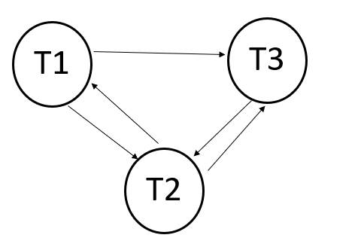

|  |  |  |
| --- | --- | --- |
| T1 | T2 | T3 |
| L(A) |  |  |
| R(A) |  |  |
| W(A) |  |  |
| L(A) |  |  |
| U(A) |  |  |
|  |  | L(A) |
|  |  | R(A) |
|  |  | W(A) |
|  | L(A) |  |
|  | R(A) |  |
| R(B) |  |  |
|  |  | L(B) |
|  |  | R(B) |
| W(B) |  |  |
| U(B) |  |  |
|  |  | W(B) |
|  |  | U(A) |
|  |  | U(B) |
|  | L(B) |  |
|  | R(B) |  |
|  | U(A) |  |
|  | U(B) |  |
|  | COMMIT |  |
| COMMIT |  |  |
|  |  | COMMIT |

**PART B:**

2pl restrictions not sufficient to avoid irrecoverable, cascading rollback and last update problem

so te ensure schedule is conflict serializable and strict recoverable we make furhter addition to 2pl to convert it to strict 2pl as follow:

**BASIC 2PL**: lock request not allowed in unlocking phase

**STRICT RECOVERABLE**: All exclusive locks of trancaction must held untill commit/Rollback if that trabsacton.